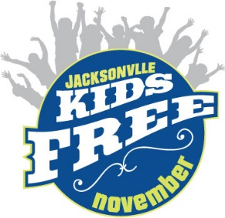

BUSINESS NAME: ___________________________________________________________________
CONTACT NAME: _____________________________________ PHONE: _______________________
EMAIL: ______________________________________
We will participate in Kids Free November with the following offer:
□#1 MAIN OFFER
Offer the main offer with these regulations:
Valid only November 1 – November 30, 2018. Up to 5 children (ages 3-12) get in FREE with a general admission paying adult. No coupon necessary. Cannot be used for special events or combined with any other discounts/offers. This offer is not intended for schools, organizations or associations.
□#2 ANOTHER KIDS FREE OFFER
If you cannot participate in the full offer above come up with an individual offer that still let’s kids in for free, for example: “For any adult ticket purchase you will receive a ticket for a child ages seven to 17 for free.” “Free meal for kids if adult entrée is purchased”
OFFER: ____________________________________________________________________________________________________________________________________________________________________________________________________________________________________________________________________________________________________________________________________________________
□#3 FREE ATTRACTIONS OFFER
For FREE Attractions that already let guests in at no cost, you of course can participate, but to be promoted on the website and in the materials you must offer something for free above and beyond what you normally do. For example: “Free Cotton Candy created on-site. One per child.” “Free coloring book for all kids visiting in November.”
OFFER:
_______________________________________________________________________________________________________________________________________________________________________________________________________________________________________________________________

